Functions

### **Encapsulate Conditionals in Functions**

Bad practice:

buttonSave.setOnClickListener {

if (itemName.*text*.*isNotEmpty*() && radiobuttonCategory.*checkedRadioButtonId* != -1 && ((checkboxRegular.*isChecked* && textviewRegularPrice.*text*.*isNotEmpty*()) || (checkboxMedium.*isChecked* && textviewMediumPrice.*text*.*isNotEmpty*()) || (checkboxLarge.*isChecked* && textviewLargePrice.*text*.*isNotEmpty*())))

saveItem()

else

Toast.makeText(

*context*,

getString(R.string.*save_error_message*),

Toast.*LENGTH_SHORT*

).show()

}

Good practice:

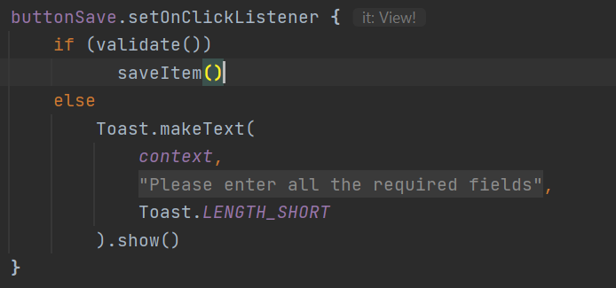

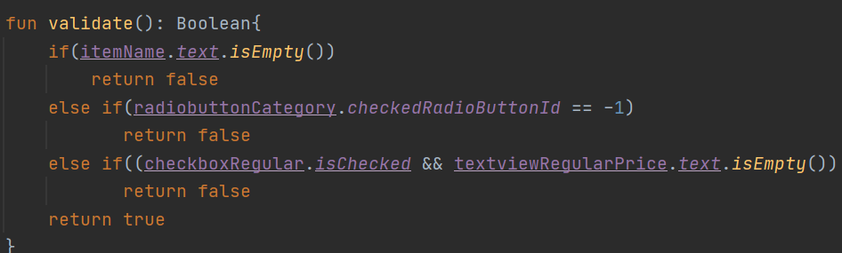

1. **Do not Repeat**

Bad practice:

Repeating the same code in more than one place.

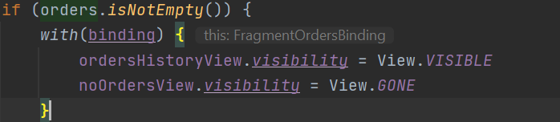

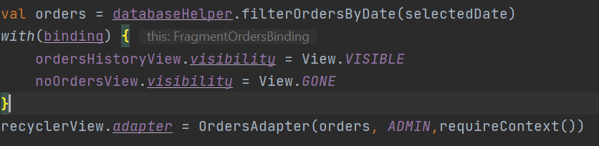

Good Practice: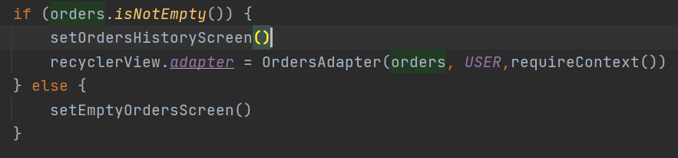

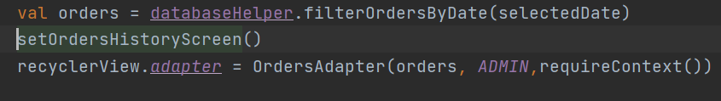

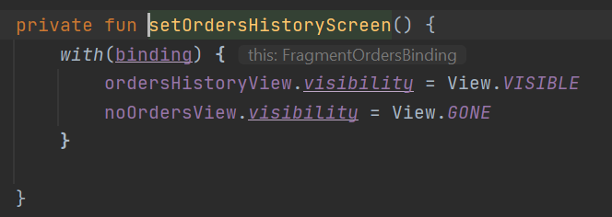

1. A Function should have only one responsibility.

Bad practice:

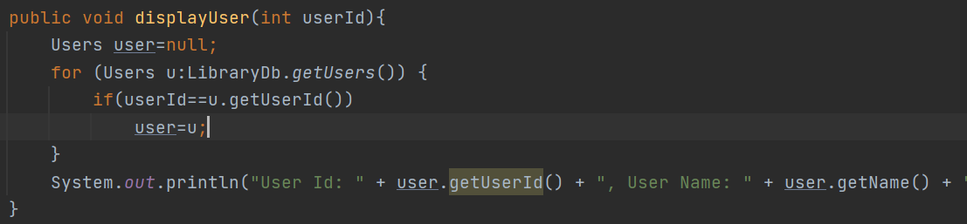

displayUser function should be responsible only for displaying the user but here it is getting user from DB and Displaying.

Good Practice:

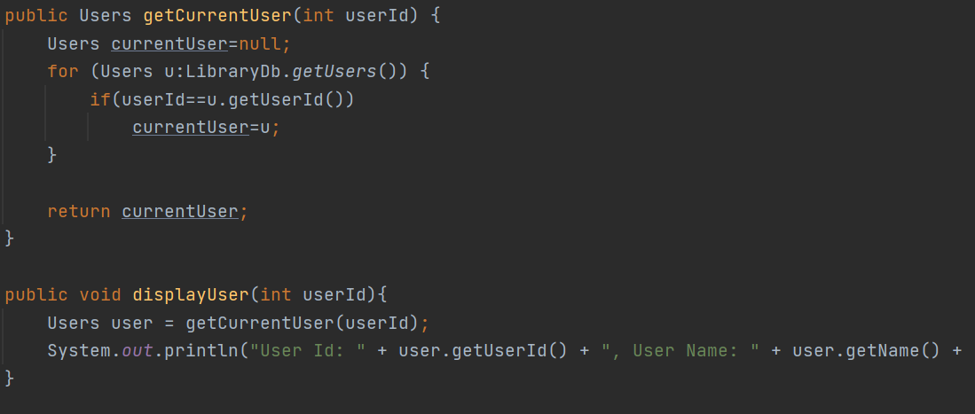

### **Do not use Flag Arguments**

Bad Practice:

private void setArgumentValues(Bundle args)

{

*isTaskEdit* = args.getInt(*KEY_TASK_TYPE*,*TASK_ADD_EVENT*) == *TASK_EDIT_EVENT*;

if(*isTaskEdit*)

{

editZuId = args.getString(CalendarUtil.*KEY_EVENT_HOST_ZUID*);

mEventTitleString = args.getString("title");//No I18N

mIsAllDayEvent = args.getBoolean("isAll");//No I18N

mStartTimeMillis = args.getLong(CalendarUtil.*KEY_START_TIME_MILLIS*);

mEndTimeMillis = args.getLong(CalendarUtil.*KEY_END_TIME_MILLIS*);

mLocationString = args.getString("location");//NO I18N

mDescriptionString = args.getString("desc");//No I18N

mAType = args.getInt("aType",-1);//NO I18N

mRType = args.getInt("rType",-1);//NO I18N

mAlarmTimeString = args.getString("alarmTime");//NO I18N

mRepeatString = args.getString("repeat");//NO I18N

mOriginalAttendeesString = args.getString("attendees"); //No I18N

mEventKey = args.getString("eKey");//NO I18N

mEventId = args.getString(ZMailConstants.*KEY_EVENT_ID*);

mCurrentCalendarId = args.getString("calId");

mCurrentCalendarName = args.getString("calName");//No I18N

}

else

{

mStartTimeMillis = args.getLong(CalendarUtil.*KEY_SELECTED_DATE_MILLIS*);

mEventTitleString = "";

mLocationString = mAlarmTimeString = mRepeatString = mOriginalAttendeesString ="";

mIsAllDayEvent = false;

mEventKey = mEventId = "";

Calendar calendar = Calendar.*getInstance*();

calendar.setTimeInMillis(mStartTimeMillis);

calendar.add(Calendar.*HOUR_OF_DAY*,1);

calendar.set(Calendar.*MINUTE*,0);

calendar.set(Calendar.*SECOND*,0);

mStartTimeMillis = calendar.getTimeInMillis();

calendar.add(Calendar.*HOUR_OF_DAY*,1);

mEndTimeMillis = calendar.getTimeInMillis();

}

}

Good Practice:

Create two functions setValuesForEditTask() and setValuesForAddTask().

*isTaskEdit* = args.getInt(*KEY_TASK_TYPE*,*TASK_ADD_EVENT*) == *TASK_EDIT_EVENT*;

if(*isTaskEdit*)

setValuesForEditTask()

else

setValuesForAddTask()